Formative Assessment Strategy Examples
Most Note Card:
This strategy gives students a way to reveal what information they recall and what information is of most significance to them. This technique can be implemented at any time during class, and is focused on actual student learning outcomes (which can then be compared to lesson objectives).

The prompt for the fill in the blank area can be chosen by the teacher in order to gain insight on a specific area of the lesson or the students may choose giving a variety of answers and assessments as far as student “take-aways”. If you want students to recall from the lesson, just stick with the 1st prompt. If you want students to go in-depth with their answers, provide the learning targets and then the students can choose which objective had the biggest impact by using that objective and providing reasoning.

On your Note Card please answer the following: What was the ___________________ that you have learned in this lesson? Give at least 3 reasons.

Possible fill in the blank prompts:
- Most important idea
- Must disturbing idea
- Most significant point
- Most unforgettable artist
- Most appealing theory
- Most surprising information
- Most powerful image
- Most memorable fact
- Most convincing argument
- Most successful inch (of an artwork)

Objectives to keep in mind:
-Given the RAFT prompt from this lesson, TSWBAT brainstorm ideal world designs that are original and well thought out.

-Shown artwork by contemporary artists and by fellow students, TSWBAT make and explain inferences about the influences and intent of the artwork.

-Using preliminary sketches, TSWBAT create an acrylic painting with a foreground, middle ground, and background light and shadow, and using primary colors to create their own colors in an effective composition.

-Given acrylic paint, TSWBAT create the illusion of 3-dimensionality by using light and shadow from a specific, identifiable light source in their acrylic landscape.

-Given acrylic painting materials, TSWBAT compose an acrylic painting that demonstrates the inherent characteristics and expressive features of art.

-Given acrylic painting materials, TSWBAT create a painting of their “ideal world/habitat” on a canvas that is critically thought out and incorporates the 5 required components decided on by the class - water, air/atmosphere, shelter, plants, and another component of their own choice.

-Using their completed acrylic paintings, TSWBAT reflect upon and discuss the use of space and value in their own artwork.

Observation Game:
This game is often used for a motivational activity, but can also be used as an assessment technique as well. It reveals students’ awareness of subject matter and compositional concerns.

Show students an original artwork (or slide) and give them a set time (3 minutes for example) to study it carefully. Then remove the image and ask students to write as much as they can remember from their observations. The teacher might designate specific categories for observation- subject matter, elements and principles, artist’s style- and ask students to look for information about these as they observe. For younger children, answers could be shared orally rather than written.

Using the Habitable Planet Lesson photos used to show foreground, middle ground and background could be used in a way to check for understanding-
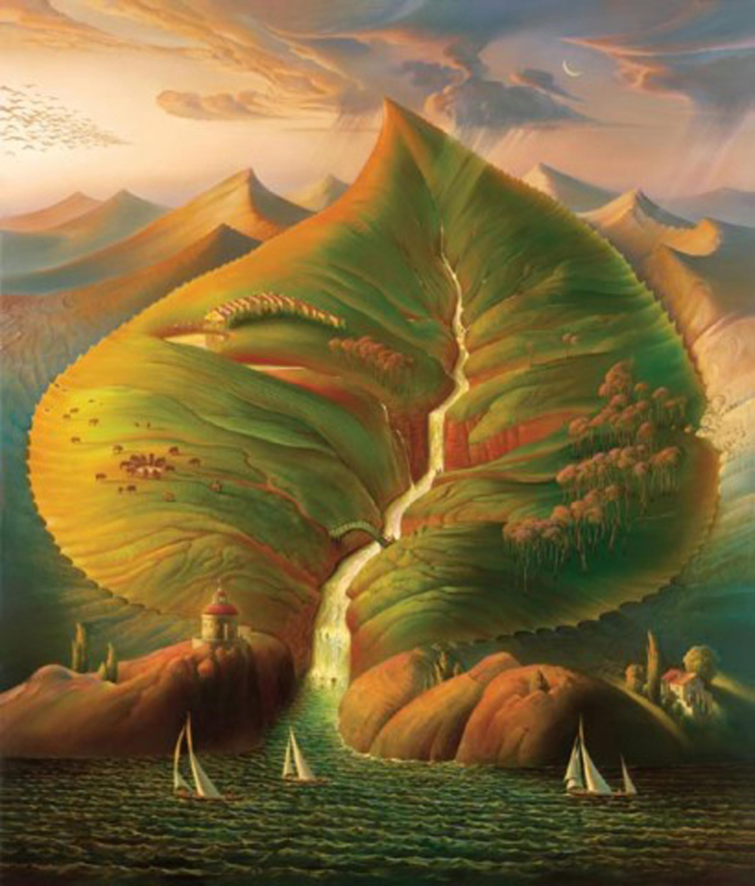

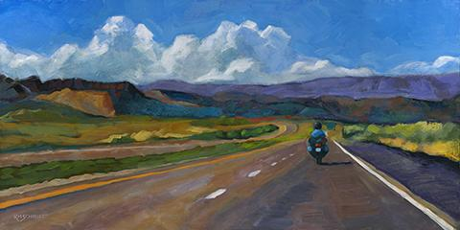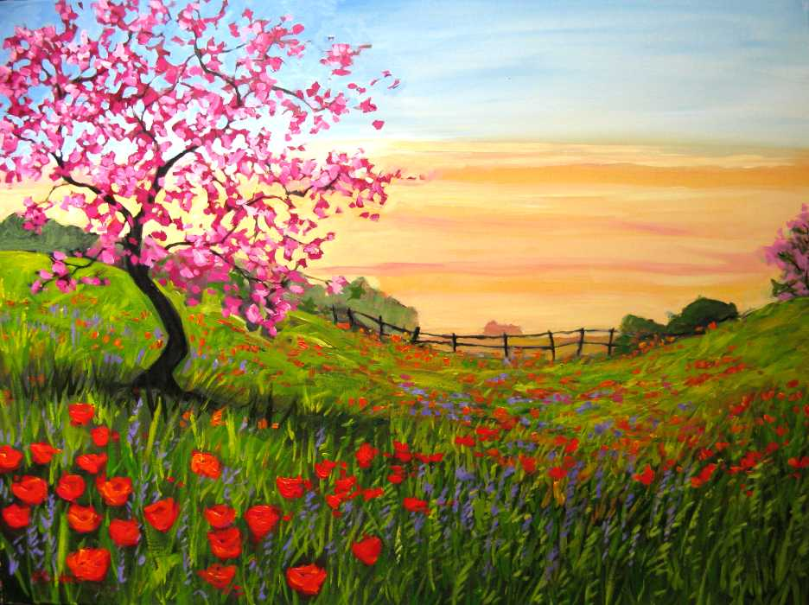

Above are a few of the artworks used to show students how to layer paint and convey depth within a painting.

By having the students write down what they see/remember from an artwork will help the teacher gather student knowledge in recognizing a particular concept (tied to lesson objectives).

